RESQGUIDE
USE-CASE DESIGN:
1. User Registration:
User creates an account.
Flow:
1.User enters name, email, password
2.System hashes password
3.User data stored in database
4.Registration successful

2. User Login:
User logs into the system.
Flow:
1.User enters email & password
2.Password verified using hash
3.JWT token generated
4.User redirected to dashboard

3,Enter Building Details
User enters building and location data.
Inputs:
1.Building type
2.Floors
3.Construction year
4.Latitude & longitude
Output: Data saved in buildings table
4.Enter Safety Measures
User selects available safety features.
Inputs:
1.Fire extinguisher
2.Emergency exit
3.CCTV
4.Medical kit
Output: Stored in safety_measures table

5.Risk Evaluation
System calculates risk score using rule-based logic.
Process:
1.Fetch building & safety data
2.Fetch location risk
3.Calculate score

6.View Risk Score
User views risk result.
Output:
1.Risk score
2.Risk level (Safe / Moderate / High)

7. Receive Disaster Alerts:
System monitors weather API and triggers alerts.
Output:
- Flood / cyclone / earthquake alert

8.View Safety Instructions
User receives disaster-specific safety steps.
9.View Safe Places
System shows nearby safe locations on map.
Process:
1.Fetch safe places
2.Calculate nearest distance
3.Display using Maps API
Logout:
User logs out securely.

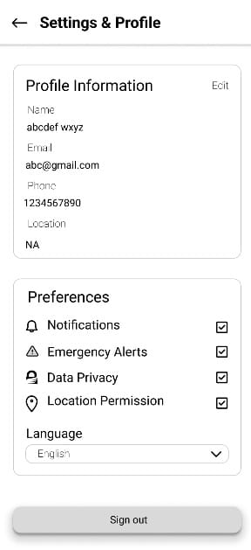 SETTINGS AND PROFILE

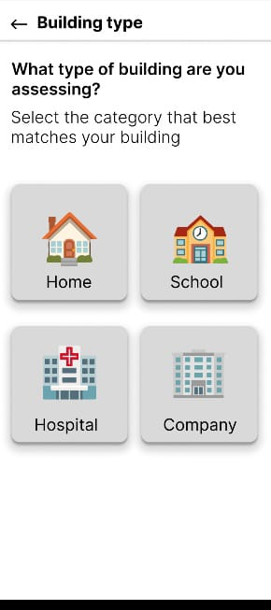
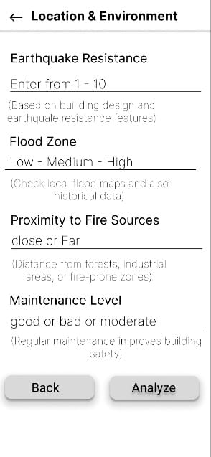`
ENTERING BUILDING TYPE AND LOCATION ENVIRONMENT.
RISKL DETECTION
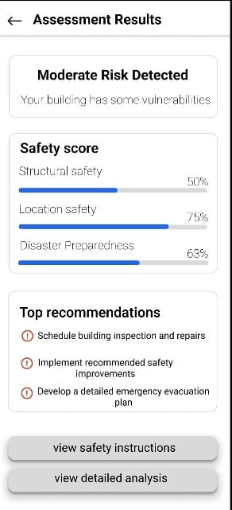
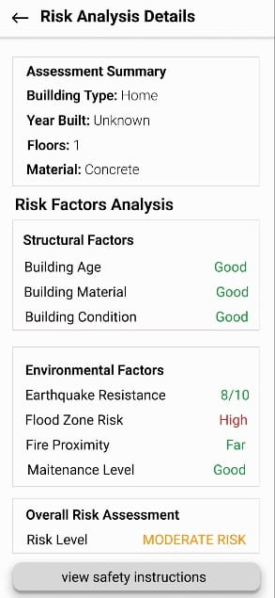
RISK ANALYSIS
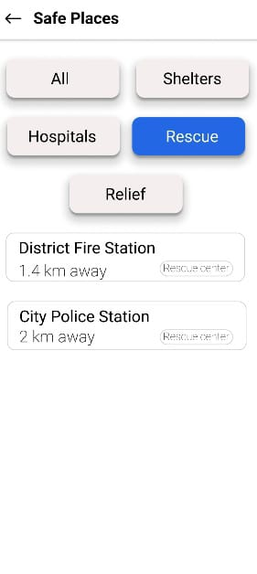
SUGGESTING SAFETY PLACES
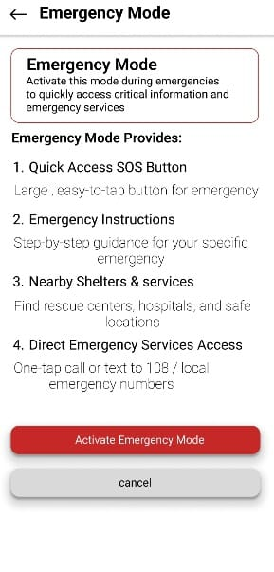
EMERGENCY MODE

